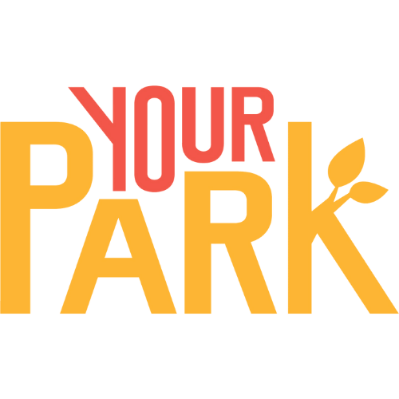
Access & Community Lead

About us
Your Park Bristol & Bath is a young charity helping everyone enjoy the health and wellbeing benefits of their local parks. We work with the people who are least likely to visit parks, including Disabled people and carers, to understand why they don’t and work together to find solutions.
Our research, ‘Not Just a Check Box’, showed the many barriers Disabled people and carers face when trying to use parks. With funding from the Heritage Lottery Fund, we’re now taking action to remove these barriers together through our ‘Parks 4 All’ project.
About the role
You’ll be in an important leadership role, leading all parts of the ‘Parks 4 All’ project. You will work closely with our partner organisations and Disabled people and carers to make parks safe, welcoming and accessible for everyone.
The project has four main parts:
- Create and share a Community Park Access Assessment Toolkit that will help community groups improve their local parks
- Improve the information available online about park accessibility
- Run regular accessible park activities such as volunteering and wellbeing sessions
- Support park groups, volunteers and Council staff to make their activities more inclusive
You will lead and project manage all parts of the project and make sure we are working with the right people and organisations across Bristol and Bath.
The Community Led Park Access Assessments are your responsibility and you will do the work to test and launch our toolkit. You will also work with the Councils to look at how to improve online information about park accessibility.
The accessible park activities and supporting park groups will be done by the Access & Community Officer who you will line manage.
We’re want applications from people with lived experience of the barriers Disabled people and carers face.
Role details
- Reports to: Programme Manager
- Line manages: Access & Community Officer
- Hours: 22.5 to 30 per week (we can be flexible and consider job shares)
- Contract: 12 months, with plans to extend
- Salary: Around £30,000 full-time equivalent (pro rata)
- Location: Mainly home-based with weekly travel around Bristol and Bath. Shared office space available at Engine Shed.
- Benefits: Pension, Employee Assistance Programme, flexible working, 25 days annual leave (pro rata), plus your birthday off and office closure at Christmas.
- Reasonable adjustments: we will make the reasonable adjustments you need for the job.

What you’ll do
- Lead and manage all aspects of the Parks 4 All project
- Build and manage partnerships with Disabled people and carers organisations and community groups
- Make sure we follow co-design principles (‘Nothing About Us Without Us’)
- Lead monitoring and evaluation with our external evaluator
- Develop and roll out the Community Park Access Assessments with our partners:
  - Organise and support community workshops as part of Community Park Access Assessments
  - Record what we learn through community workshops to keep updating the toolkit
  - Find and work with a design agency to make the Community Park Access Assessment Toolkit
- Lead work to get people across the country using the toolkit
- Help make a digital platform with up-to-date park access information
- Oversee accessible activities and line manage the Access & Community Officer
- Represent us at events and build relationships with councils, funders and other partners

What we’re looking for
Essential
- Strong knowledge of local Disabled people’s and carers’ issues and networks
- Understanding of barriers to parks and the Social Model of Disability
- Good at building partnerships and working with different people
- Strong leadership, project management and organisational skills
- Able to think creatively and solve problems
- Experience of co-design and working with communities
- Experience organising workshops and community activities
- Inclusive and empathetic
- Understanding of evaluation and monitoring processes
- Line management experience
- Being creative, making links and seeing the big picture
- Ready to work in a small, fast-paced and changing environment
- Passionate about parks and improving access for all

Desirable
- Lived experience of barriers to parks
- Experience managing budgets and reporting to funders
- Knowledge of accessibility standards
- Experience working with design or creative agencies
- Knowledge of Asset Based Community Development
- Facilitation experience
- Experience of influencing decision makers

Other
- You’ll need or be willing to get an Enhanced DBS check

Diversity and inclusion
We welcome applications from all backgrounds and want to receive applications from Disabled people, carers, from ethnically diverse backgrounds, on low incomes or from underrepresented groups.
If you meet the essential criteria and are Disabled or from an ethnic minority background, you can ask to be considered under our guaranteed interview scheme in your cover letter.

How to apply
Please email your CV and a covering letter (maximum two pages) explaining how you meet the requirements to jobs@yourpark.org.uk.
Applications close on Sunday 17th August at midnight.
Interviews will take place in September when the school holidays are over.
If you need any adjustments to apply, please contact us at jobs@yourpark.org.uk or call 07742 881566.

